**Exp. 15 Establishing remote connection**

**Aim:**

To demonstrate Infrastructure as a Service (IaaS) by establishing the remote

connection, launching the created VM image and run in your desktop.

**Procedure:**

* Sign in to Azure Portal
* Click on the virtual machine you created, then click on connect\
* Check the VM access, if access is clear, then start the VM\
* Click on “Download RPD file”
* Then enter username and password
* Now the virtual machine will run as a remote connection

**Output:**

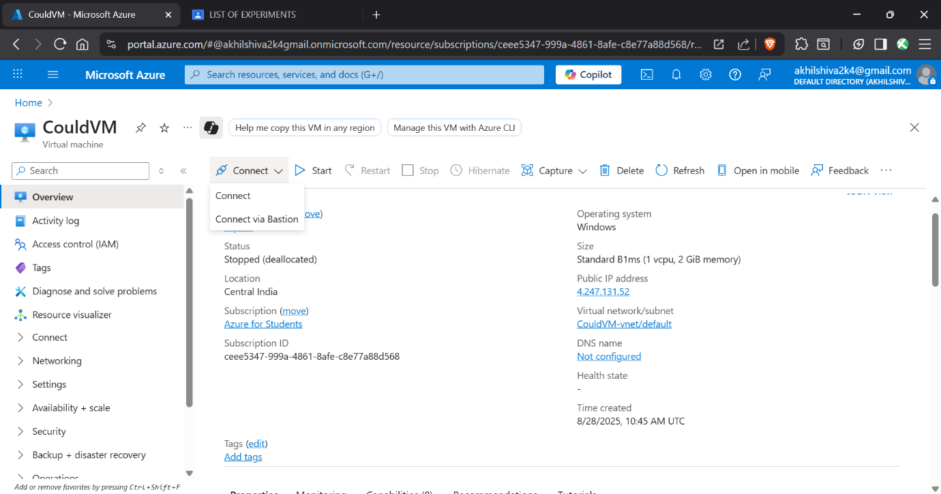

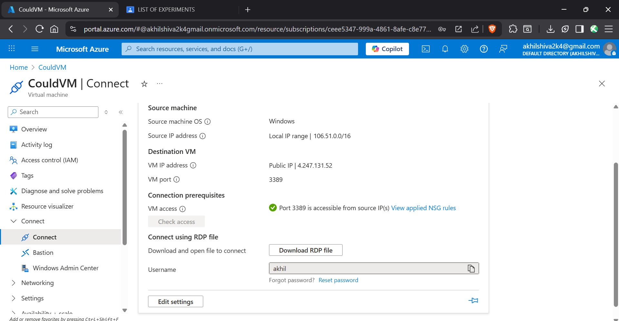

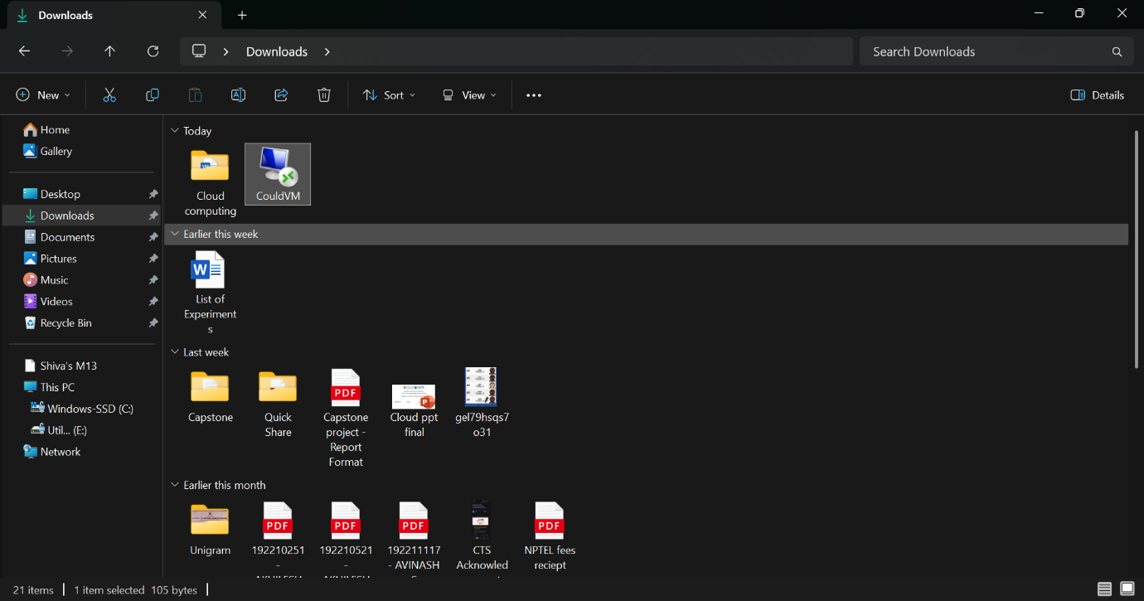

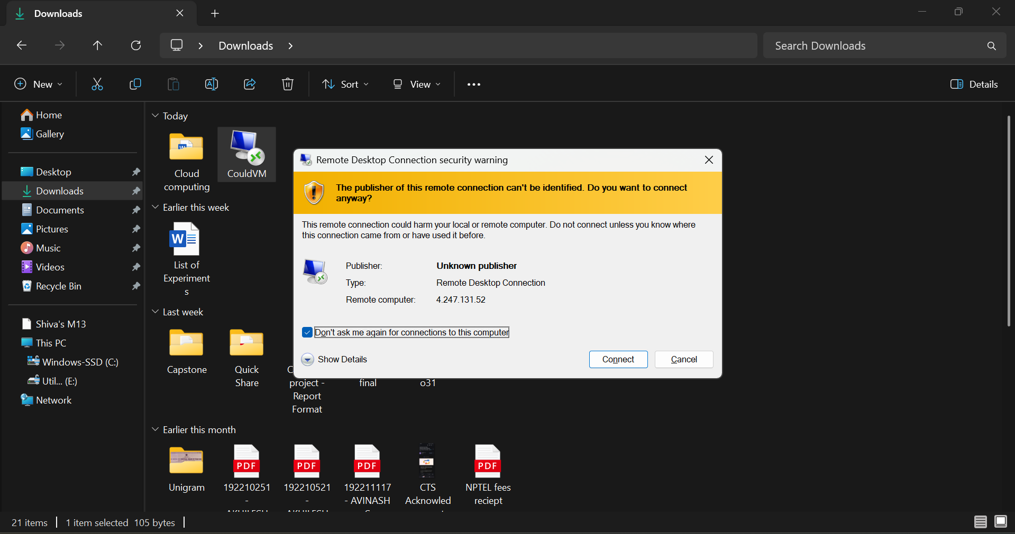

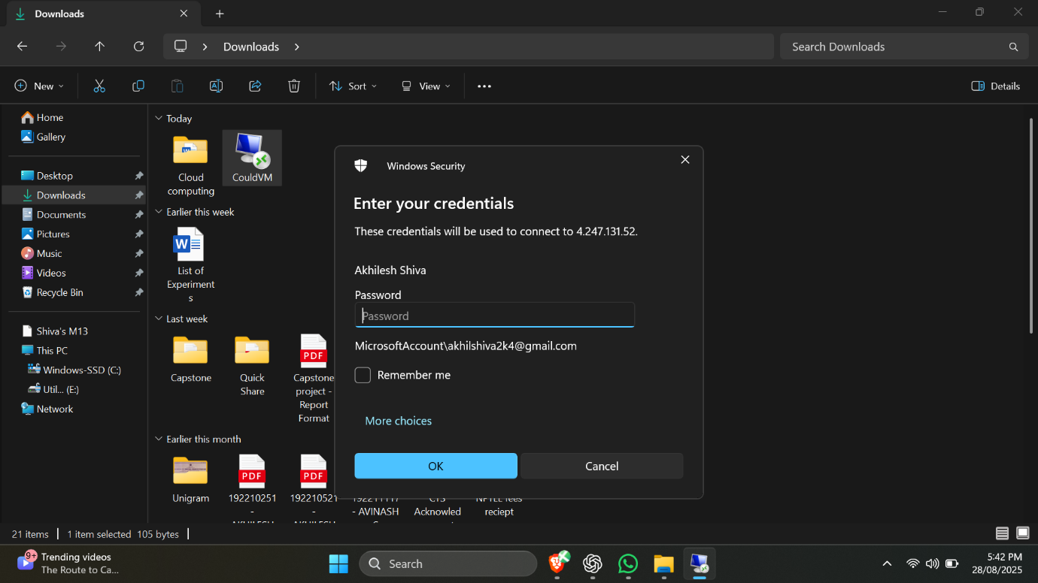

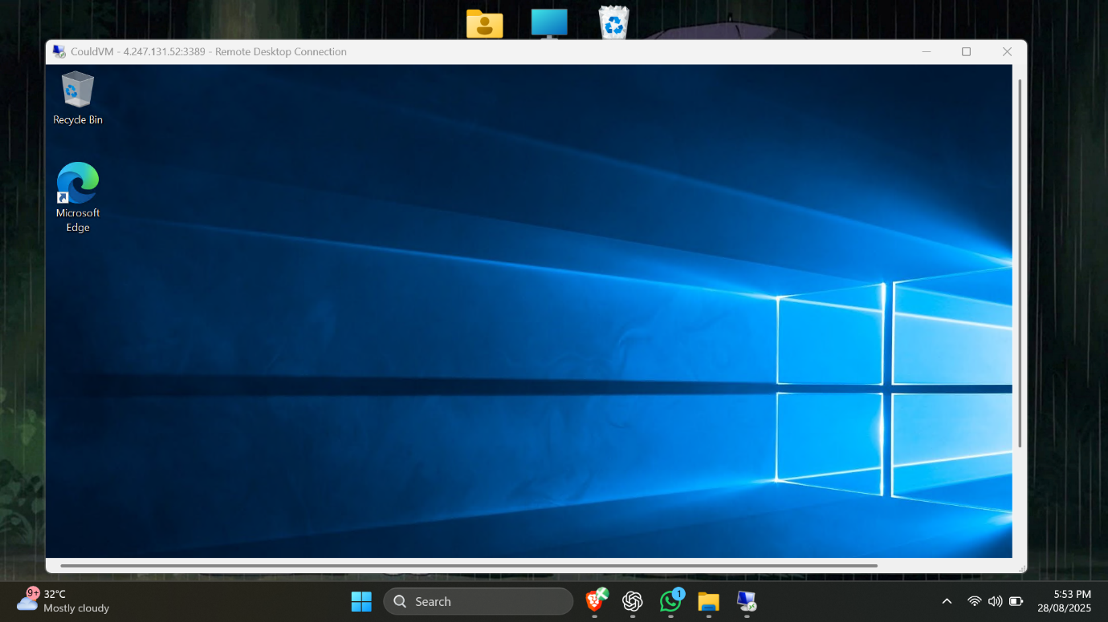

**Result:**

Thus the remote connection was successfully established using Azure